Copyright reserved

Please turn over

**NATIONAL CERTIFICATE**

**STRENGTH OF MATERIALS AND STRUCTURES N6**

**AUGUST 2018**

**6**

**This marking guideline consists of 8 pages.**



**MARKING GUIDELINE**

# QUESTION 1

1.1 𝑏𝑏

𝑎𝑎𝑎𝑎 80 𝑚𝑚𝑚𝑚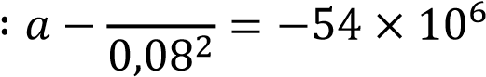 … … … . (1) ✓

𝑏𝑏

𝑎𝑎𝑎𝑎 120 𝑚𝑚𝑚𝑚 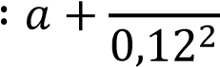= 0 … … … … … … . . (2)✓

(1) − (2) ∶ 156,25𝑏𝑏 − 69,444𝑏𝑏 = −54 × 106

𝑏𝑏 = 239,262 × 103 ✓

𝑎𝑎 = −16,615 × 106✓

𝑏𝑏

## 𝑎𝑎𝑎𝑎 80 𝑚𝑚𝑚𝑚

6 − 239,2620,08×2 103

= −16,615 × 10

𝜎𝜎𝑅𝑅 = 20,769 𝑀𝑀𝑀𝑀𝑎𝑎 ✓ (5)

1.2 𝑊𝑊 = 𝑝𝑝 × 𝐴𝐴 = 20,769 × 106 × 𝜋𝜋 × 0,042 = 104,398 𝑘𝑘𝑘𝑘✓

𝑊𝑊 104,398 × 103

𝑚𝑚 = = = 10641,951 𝑘𝑘𝑔𝑔✓

𝑔𝑔 9,81 (2)

1.3 𝑝𝑝𝑑𝑑2 20,769 × 106 × 0,082

𝜎𝜎𝐿𝐿 = 𝐷𝐷2 − 𝑑𝑑2 = 0,122 − 0,082 ✓ = 16,615 𝑀𝑀𝑀𝑀𝑎𝑎✓ (2)

1.4 (𝜎𝜎𝐻𝐻 − 𝜗𝜗 × 𝜎𝜎𝑅𝑅) −54 × 106 − 0,29 × 20,769 × 106 −6✓

𝜖𝜖 = 𝐸𝐸 = 200 × 109 ✓ = −300,115 × 10 (2)

1.5 ∆𝑑𝑑 = 𝜀𝜀 × 𝑑𝑑 = −300,115 × 10−6 × 0,08✓ = 24,009 × 10−6 𝑚𝑚✓ (2)

# [13] QUESTION 2

## 2.1 𝐶𝐶𝐶𝐶𝐶𝐶𝐶𝐶𝐶𝐶𝑑𝑑𝐶𝐶𝐶𝐶 𝑎𝑎ℎ𝐶𝐶 𝑑𝑑𝐶𝐶𝑑𝑑𝑑𝑑𝐶𝐶𝑑𝑑𝑎𝑎𝐶𝐶𝐶𝐶𝐶𝐶 𝑑𝑑𝐶𝐶𝑚𝑚𝐶𝐶𝑎𝑎

𝑤𝑤𝑑𝑑14 𝑤𝑤𝑑𝑑13 × 𝑑𝑑2

∆= +

## 8𝐸𝐸𝐸𝐸 6𝐸𝐸𝐸𝐸

10 × 103 × 44 10 × 103 × 43 × 3

0,013 = 8 × 200 × 109 × 𝐸𝐸 + 6 × 200 × 109 × 𝐸𝐸 ✓ 𝐸𝐸 = 246,154 × 10−6 𝑚𝑚4✓

𝑆𝑆𝐶𝐶𝑑𝑑𝐶𝐶𝑑𝑑𝑎𝑎 457 × 191 × 67,1 𝑘𝑘𝑔𝑔/𝑚𝑚✓

## 𝐶𝐶𝐶𝐶𝐶𝐶𝐶𝐶𝐶𝐶𝑑𝑑𝐶𝐶𝐶𝐶 𝑎𝑎ℎ𝐶𝐶 𝐶𝐶𝑎𝑎𝐶𝐶𝐶𝐶𝐶𝐶𝐶𝐶 𝑑𝑑𝐶𝐶𝑚𝑚𝐶𝐶𝑎𝑎

𝑤𝑤𝑑𝑑2 10 × 103 × 42

𝑀𝑀 = = = 80 𝑘𝑘𝑘𝑘𝑚𝑚✓

2 2

𝑀𝑀 80 × 103

𝑍𝑍 = = = 888,889 × 10−6 𝑚𝑚3✓

|  |  |  |  |
| --- | --- | --- | --- |
|  | 𝜎𝜎 90 × 106  𝑆𝑆𝐶𝐶𝑑𝑑𝐶𝐶𝑑𝑑𝑎𝑎 406 × 178 × 53,8 𝑘𝑘𝑔𝑔/𝑚𝑚✓  𝐶𝐶𝐶𝐶𝐶𝐶𝐶𝐶𝐶𝐶𝑑𝑑𝑎𝑎 𝑝𝑝𝐶𝐶𝐶𝐶𝑑𝑑𝐶𝐶𝑑𝑑𝐶𝐶 = 457 × 191 × 67,1 𝑘𝑘𝑔𝑔/𝑚𝑚✓  𝑇𝑇ℎ𝐶𝐶𝐶𝐶 𝑝𝑝𝐶𝐶𝐶𝐶𝑑𝑑𝐶𝐶𝑑𝑑𝐶𝐶 𝑤𝑤𝐶𝐶𝑑𝑑𝑑𝑑 𝐶𝐶𝑎𝑎𝑎𝑎𝐶𝐶𝐶𝐶𝑑𝑑𝑠𝑠 𝑏𝑏𝐶𝐶𝑎𝑎ℎ 𝑑𝑑𝐶𝐶𝑚𝑚𝐶𝐶𝑎𝑎𝐶𝐶✓ |  | (8) |
| 2.2 | 𝑤𝑤𝑑𝑑14 𝑤𝑤𝑑𝑑13 × 𝑑𝑑2  ∆= +  8𝐸𝐸𝐸𝐸 6𝐸𝐸𝐸𝐸 |  |  |
| 10 × 103 × 44 10 × 103 × 43 × 3 |

# = + ✓

|  |  |  |
| --- | --- | --- |
| 8 × 200 × 109 × 294,1 × 10−6 6 × 200 × 109 × 294,1 × 10−6 |  | (4)  **[12]** |
| ∆= 10,88 𝑚𝑚𝑚𝑚✓    𝑀𝑀 80 × 103  𝜎𝜎 = = −6 ✓ = 61,681 𝑀𝑀𝑀𝑀𝑎𝑎✓ 𝑍𝑍 1297 × 10      **QUESTION 3** |
| 3.1 𝐹𝐹 180 × 103  𝜎𝜎𝑑𝑑 = = −3 ✓ = 50,364 𝑀𝑀𝑀𝑀𝑎𝑎✓  𝐴𝐴 2 × 1,787 × 10 |  | (2) |
| 3.2 𝑤𝑤𝐿𝐿2 2 × 137,34 × 42  𝑀𝑀 = = = 2,197 𝑘𝑘𝑘𝑘𝑚𝑚✓  2 2    𝑀𝑀𝑀𝑀 2,197 × 103 × 0,0241 |  |  |
| 𝜎𝜎𝑏𝑏𝑏𝑏𝑏𝑏𝑏𝑏 = = −6 = 26,0365 𝑀𝑀𝑀𝑀𝑎𝑎✓ (𝑎𝑎𝐶𝐶𝐶𝐶𝐶𝐶𝐶𝐶𝑑𝑑𝐶𝐶)✓  𝐸𝐸 2 × 1,017 × 10    𝑀𝑀𝑀𝑀 2,197 × 103 × 0,0559  𝜎𝜎𝑏𝑏𝑏𝑏𝑏𝑏𝑏𝑏 = = −6 = 60,392 𝑀𝑀𝑀𝑀𝑎𝑎✓(𝑑𝑑𝐶𝐶𝑚𝑚𝑝𝑝𝐶𝐶𝐶𝐶𝐶𝐶𝐶𝐶𝐶𝐶𝑐𝑐𝐶𝐶)✓ |

𝐸𝐸 2 × 1,017 × 10 (5)

3.3 𝜎𝜎𝑏𝑏𝑏𝑏𝑏𝑏 = 𝜎𝜎𝑑𝑑 + 𝜎𝜎𝑏𝑏 = 50,364 + 26,0365 = 76,4 𝑀𝑀𝑀𝑀𝑎𝑎 ✓ (𝑎𝑎𝐶𝐶𝐶𝐶𝐶𝐶𝐶𝐶𝑑𝑑𝐶𝐶)✓

𝜎𝜎𝑏𝑏𝑏𝑏𝑏𝑏 = 𝜎𝜎𝑑𝑑 − 𝜎𝜎𝑏𝑏 = 50,364 − 60,392 = 10,028 𝑀𝑀𝑀𝑀𝑎𝑎 ✓ (𝑑𝑑𝐶𝐶𝑚𝑚𝑝𝑝𝐶𝐶𝐶𝐶𝐶𝐶𝐶𝐶𝐶𝐶𝑐𝑐𝐶𝐶)✓ (4)

3.4 𝑥𝑥 80 − 𝑥𝑥

= ✓

76,4 10,028

= 70,7 𝑚𝑚𝑚𝑚 𝑑𝑑𝐶𝐶𝐶𝐶𝑚𝑚 𝑎𝑎ℎ𝐶𝐶 𝑎𝑎𝐶𝐶𝑝𝑝✓

76,4

N

A

70

,

7

✓

✓

10,028 (4)

**[15]**

## QUESTION 4

4.1 𝑊𝑊1 = 𝜌𝜌𝑔𝑔𝐴𝐴𝑑𝑑 = 2200 × 9,81 × 0,5 × 4 × 𝑠𝑠 × 1 = 43,164𝑠𝑠 𝑘𝑘𝑘𝑘✓

𝑊𝑊2 = 𝜌𝜌𝑔𝑔𝐴𝐴𝑑𝑑 = 2200 × 9,81 × 1,5 × 4 × 1 = 129,492 𝑘𝑘𝑘𝑘✓ 𝑉𝑉 = 𝑊𝑊1 + 𝑊𝑊2 = 43,164𝑠𝑠 + 129,492 𝑘𝑘𝑘𝑘 ✓

𝑉𝑉 6𝑉𝑉𝐶𝐶

𝜎𝜎𝑏𝑏𝑏𝑏𝑏𝑏 = 𝐵𝐵 + 𝐵𝐵2 − − − (1)✓

𝑉𝑉 6𝑉𝑉𝐶𝐶

### 𝜎𝜎𝑏𝑏𝑏𝑏𝑏𝑏 = 𝐵𝐵 − 𝐵𝐵2 − − − (2)✓

2𝑉𝑉

(1) + (2): 91,342 + 38,15 = ✓

𝐵𝐵

2(43,164𝑠𝑠 + 129,492) 129,492 =✓

1,5 + 𝑠𝑠

129,492 × (1,5 + 𝑠𝑠) = 2(43,164𝑠𝑠 + 129,492)✓

𝑠𝑠 = 1,5 𝑚𝑚 ✓ 𝑎𝑎𝐶𝐶𝑑𝑑 𝐵𝐵 = 1,5 + 1,5 = 3 𝑚𝑚 ✓ (10)

4.2 𝑉𝑉 = 43,164𝑠𝑠 + 129,492 = 43,164 × 1,5 + 129,492 = 194,238 𝑘𝑘𝑘𝑘✓

𝑉𝑉 194,238

𝜎𝜎𝑑𝑑 = = = 64,746 𝑘𝑘𝑀𝑀𝑎𝑎✓

### 𝐵𝐵 3

𝜎𝜎𝑏𝑏 = 𝜎𝜎𝑏𝑏𝑏𝑏𝑏𝑏 − 𝜎𝜎𝑑𝑑 = 91,342 − 64,746 ✓ = 26,596 𝑘𝑘𝑀𝑀𝑎𝑎✓ (4)

**[14]**

## QUESTION 5

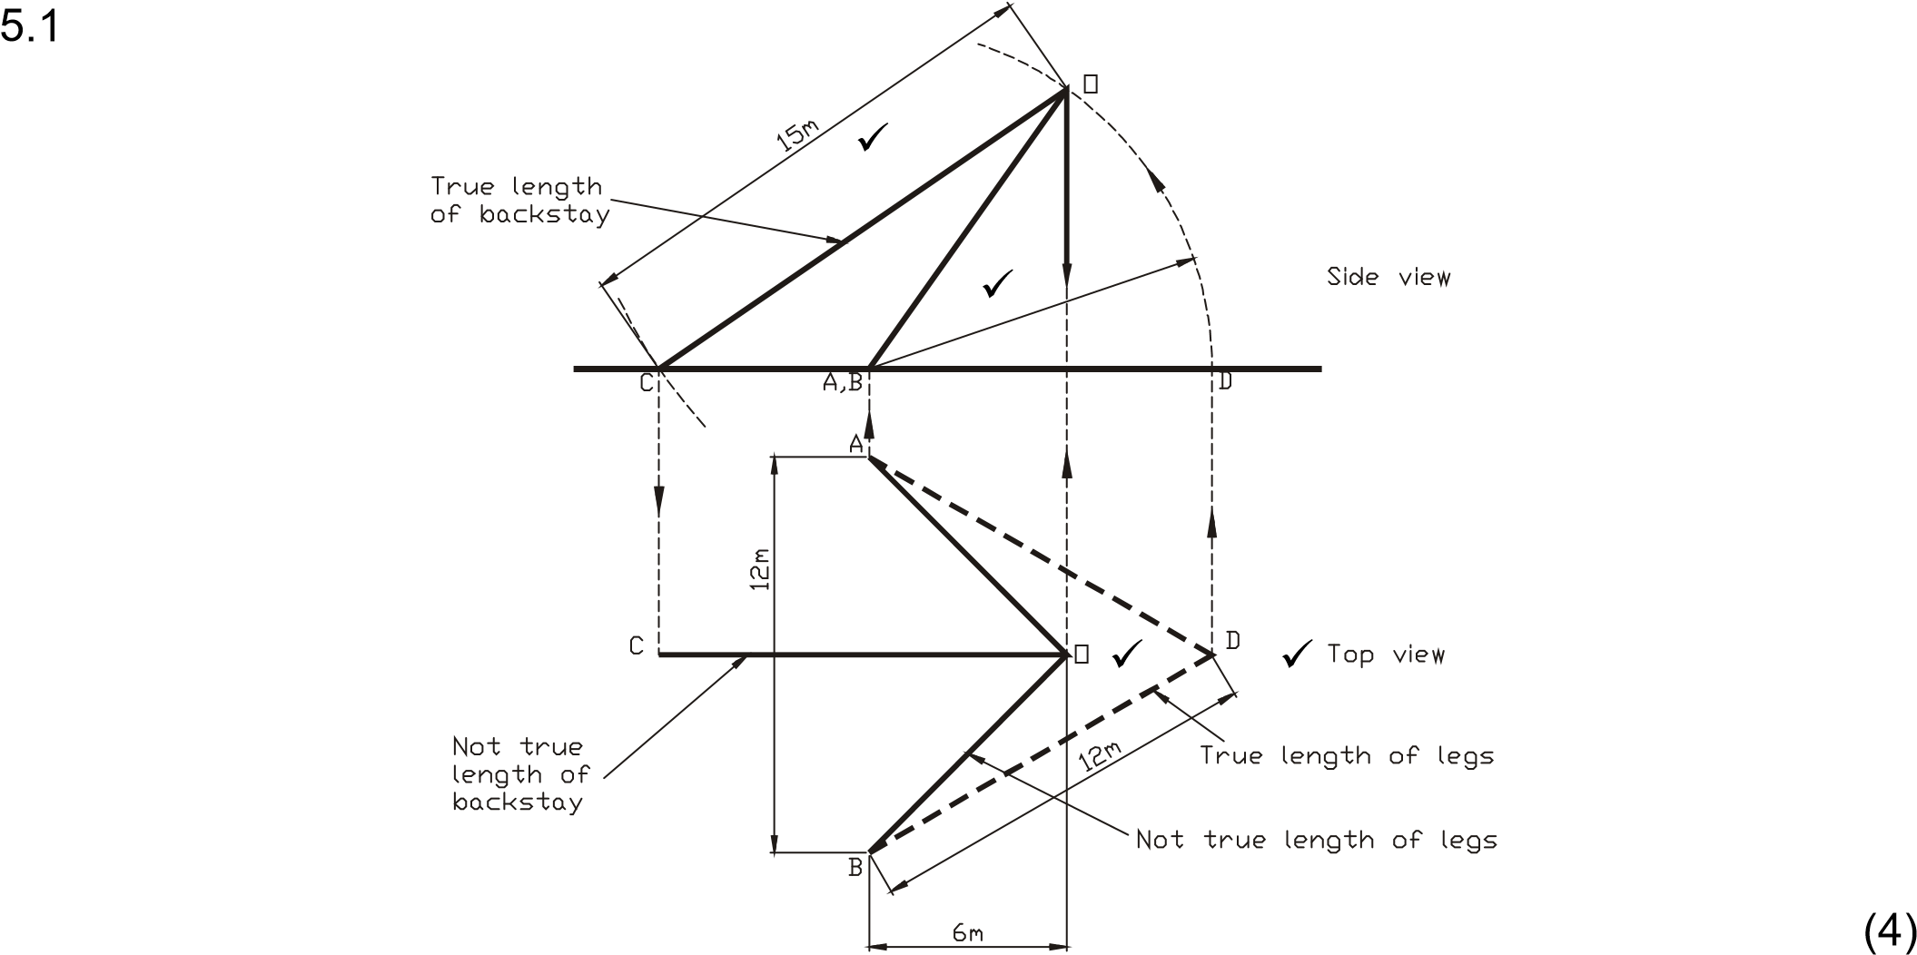

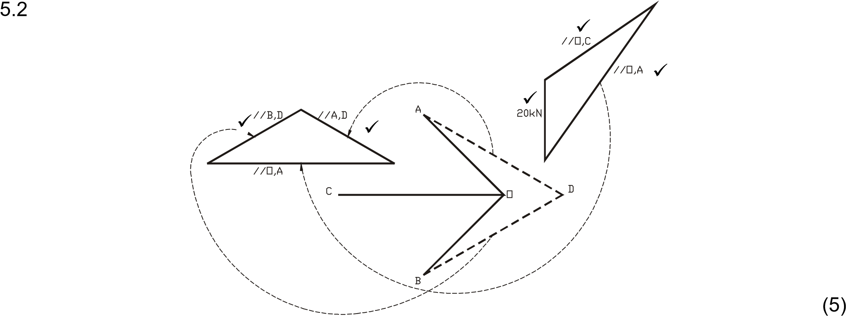

|  |  |  |
| --- | --- | --- |
| MEMBER | MAGNITUDE | NATURE |
| OC | 33,3 kN √ | TIE √ |
| OA | 27,4 kN √ | STRUT √ |
| OB | 27,4 kN √ | STRUT √ |

5.3

(3)

**[12]**

## QUESTION 6

### 6.1 𝜎𝜎𝑠𝑠 𝑚𝑚(𝑑𝑑 −𝐶𝐶) 𝜎𝜎𝑐𝑐 𝐶𝐶

=

140 15(0,8 − 𝐶𝐶)

= ✓

7 𝐶𝐶

𝐶𝐶 = 0,343 𝑚𝑚✓ (2)

6.2 𝑀𝑀 = 0,5𝜎𝜎𝑐𝑐𝐴𝐴𝑐𝑐𝑑𝑑𝑏𝑏 = 0,5 × 7 × 106 × 0,35 × 0,343 × 0,686✓ = 288 𝑘𝑘𝑘𝑘𝑚𝑚✓ (2)

### 6.3 𝑀𝑀 = 𝜎𝜎𝑠𝑠𝐴𝐴𝑠𝑠𝑑𝑑𝑏𝑏

288 × 103 = 140 × 106 × 𝐴𝐴𝑠𝑠 × 0,686✓

𝐴𝐴𝑠𝑠 = 3 × 10−3 𝑚𝑚2 ✓

𝑆𝑆𝐶𝐶𝑑𝑑𝐶𝐶𝑑𝑑𝑎𝑎 203 × 102 × 25.3 𝑘𝑘𝑔𝑔/𝑚𝑚✓ (3)

### 6.4 𝑀𝑀 = 𝜎𝜎𝑠𝑠𝐴𝐴𝑠𝑠𝑑𝑑𝑏𝑏

288 × 103 = 𝜎𝜎𝑠𝑠 × 3,226 × 10−3 × 0,686✓

𝜎𝜎𝑠𝑠 = 130,192 𝑀𝑀𝑀𝑀𝑎𝑎✓ (2)

6.5

𝑀𝑀𝑐𝑐 = 0,5𝜎𝜎𝑐𝑐𝐴𝐴𝑐𝑐𝐶𝐶

= 0,5 × 7 × 106 × 0,35 × 0,343 ×  × 0,343✓

𝑀𝑀𝑐𝑐 = 96 𝑘𝑘𝑘𝑘𝑚𝑚✓

### 𝑀𝑀𝑠𝑠 = 𝜎𝜎𝑠𝑠𝐴𝐴𝑠𝑠(𝑑𝑑 − 𝐶𝐶)

= 130,192 × 106 × 3,226 × 10−6(0,8 − 0,343)✓

𝑀𝑀𝑠𝑠 = 192 𝑘𝑘𝑘𝑘𝑚𝑚 ✓ (4)

## [13] QUESTION 7

7.1

𝑥𝑥

=

𝑑𝑑

### 𝐿𝐿 − 𝑥𝑥 𝑑𝑑 + ℎ

= 8

𝑥𝑥

✓

130 − 𝑥𝑥 12

𝑥𝑥 = 58,434 𝑚𝑚✓ (2)

7.2 𝑤𝑤𝑥𝑥12 12 × 58,4342

𝐹𝐹𝐻𝐻 = 2𝑑𝑑 = 2 × 8 = 2560,87 𝑘𝑘𝑘𝑘✓

𝐹𝐹𝑉𝑉2 = 𝑤𝑤𝑥𝑥2 = 12 × 71,566 = 858,796 𝑘𝑘𝑘𝑘✓

2 + 𝐹𝐹𝑉𝑉22 = 2560,872 + 858,7962 = 2701,0342 𝑘𝑘𝑘𝑘✓  (3)

### 𝐹𝐹𝑇𝑇2 = 𝐹𝐹𝐻𝐻

7.3 𝐹𝐹𝑉𝑉𝑏𝑏 = 𝐹𝐹𝐻𝐻 tan 𝜃𝜃 = 2560,87 × tan 40 = 2148,825 𝑘𝑘𝑘𝑘✓

𝑅𝑅 = 𝐹𝐹𝑉𝑉2 + 𝐹𝐹𝑉𝑉𝑏𝑏 = 858,796 + 2148,825 = 3007,621 𝑘𝑘𝑘𝑘✓ (2)

7.4 𝑥𝑥3 = 80 − 58,434 = 21,566 𝑚𝑚✓

𝐹𝐹𝑉𝑉3 = 𝑤𝑤𝑥𝑥3 = 12 × 21,566 = 258,796 𝑘𝑘𝑘𝑘✓

2 + 𝐹𝐹𝑉𝑉32 = 2560,872 + 258,7862 = 2573,914 𝑘𝑘𝑘𝑘✓ (3)

𝐹𝐹𝑇𝑇3 = 𝐹𝐹𝐻𝐻

**[10]**

## QUESTION 8

8.1 𝜏𝜏 = 𝜏𝜏𝑢𝑢𝑢𝑢𝑢𝑢 200

= = 50 𝑀𝑀𝑀𝑀𝑎𝑎✓

𝐹𝐹𝐹𝐹𝑆𝑆 4

𝜋𝜋(𝐷𝐷4 − 𝑑𝑑4)𝜏𝜏 𝜋𝜋(0,14 − 0,0754) × 50 × 106

𝑇𝑇𝑒𝑒 = 16𝐷𝐷 = 16 × 0,1 ✓ = 6711,166 𝑘𝑘𝑚𝑚✓

### 𝑇𝑇𝑒𝑒 = 𝑇𝑇2 + 𝑀𝑀2

6711,166 = (𝑇𝑇)2 + (3𝑇𝑇)2✓

𝑇𝑇 = 2122,257 𝑘𝑘𝑚𝑚✓

𝑀𝑀 = 6366,771 𝑘𝑘𝑚𝑚✓ (6)

8.2 𝑀𝑀𝑒𝑒 = 0,5(𝑀𝑀 + 𝑇𝑇𝑒𝑒)

= 0,5(6366,771 + 6711,166)

𝑀𝑀𝑒𝑒 = 6538,968 𝑘𝑘𝑚𝑚✓

32 × 𝑀𝑀𝑒𝑒 × 𝐷𝐷 32 × 6538,968 × 0,1

𝜎𝜎 = 𝜋𝜋 × (𝐷𝐷4 − 𝑑𝑑4) = 𝜋𝜋 × (0,14 − 0,0754) ✓ = 97,434 𝑀𝑀𝑀𝑀𝑎𝑎✓ (3)

8.3 3 = 𝐷𝐷4 − 𝑑𝑑4 = 0,14 − 0,0754 = 683,59375 × 10−6✓

### 𝑑𝑑

𝐷𝐷 0,1

𝑑𝑑 = 88,1 𝑚𝑚𝑚𝑚✓ (2)

**[11]**

## TOTAL: 100

Copyright reserved